**Lab Steps**

Task 1: Sign in to AWS Management Console

1. Click on the Open Console button, and you will get redirected to AWS Console in a new browser tab.

2. On the AWS sign-in page,

· Leave the Account ID as default

·Now enter your username and password.

3. click on sign-in.

4.After signing in select US East (N. Virginia) us-east- as AWS region.

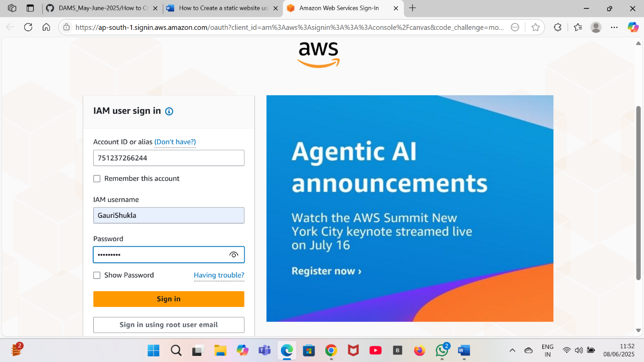

**Task 2: Creating an S3 Bucket:**

1. Click on search bar and enter S3 and then click on S3.
2. On the left side click on buckets and then click on create bucket.
3. Enter the details:

**Bucket name**: Enter source bucket name.

**Region**: Select US East (N. Virginia) us-east-1.

**Object ownership**: Select ACLs disabled.

Bucket settings for Block Public Access, Uncheck the option of Block all public access.

And, Acknowledge the same by checking the below option.

1. Keep all other options as default.
2. Now click on create bucket.
3. Now your bucket has been created.



Task 3: Upload an Object:

1. Click on the bucket which you have created.
2. Click on **Upload** . Now click on add file and select any file which you want to upload.
3. Now click on **Upload.**
4. Your file will be upload in the bucket.

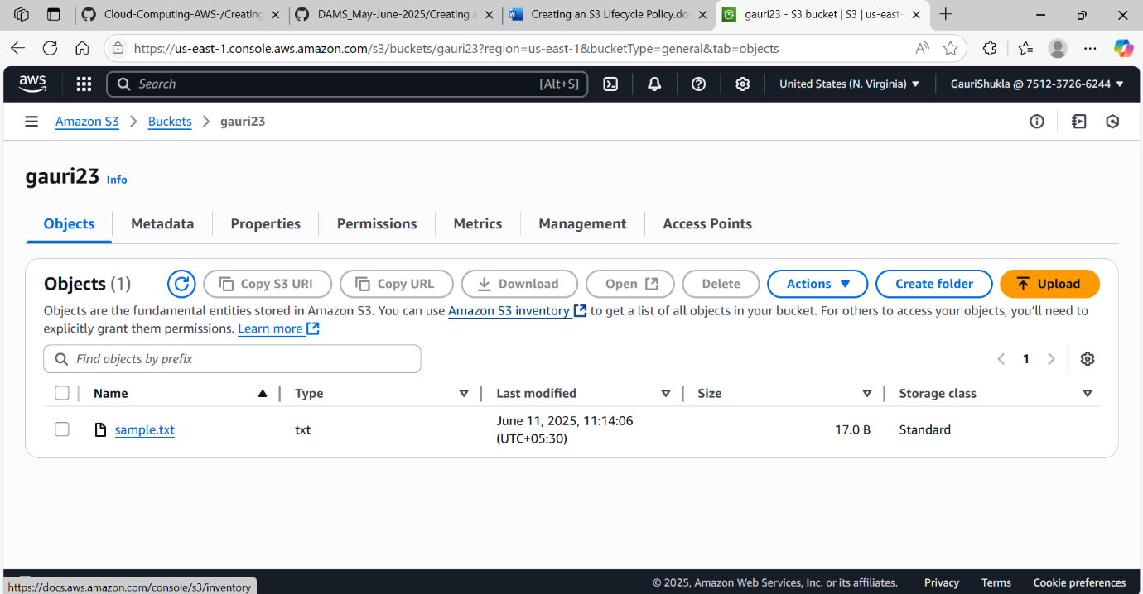

Task 4: Creating a Lifecycle Rule:

1. Click on the S3 bucket you have created.
2. Now click on Management tab.
3. Under Lifecycle Rule click on Create Lifecycle Rule
4. Lifecycle Rule name: Enter test

And check the I acknowledge box.

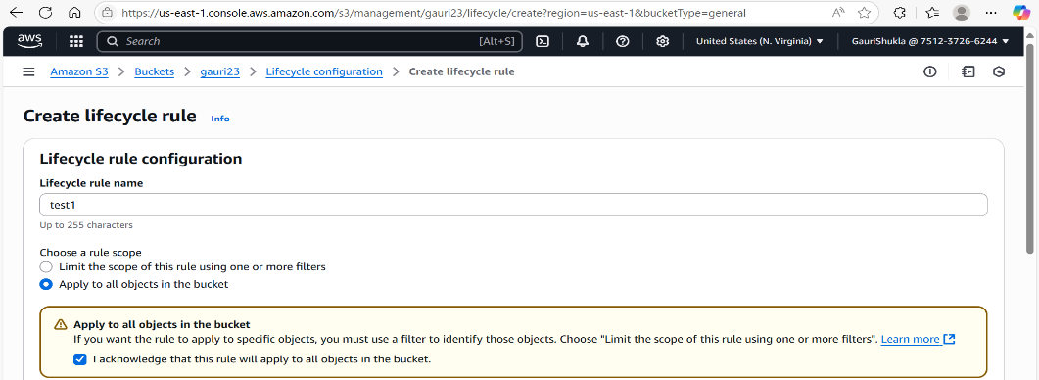

1. Under Lifecycle rule action: Select the following checkboxes.

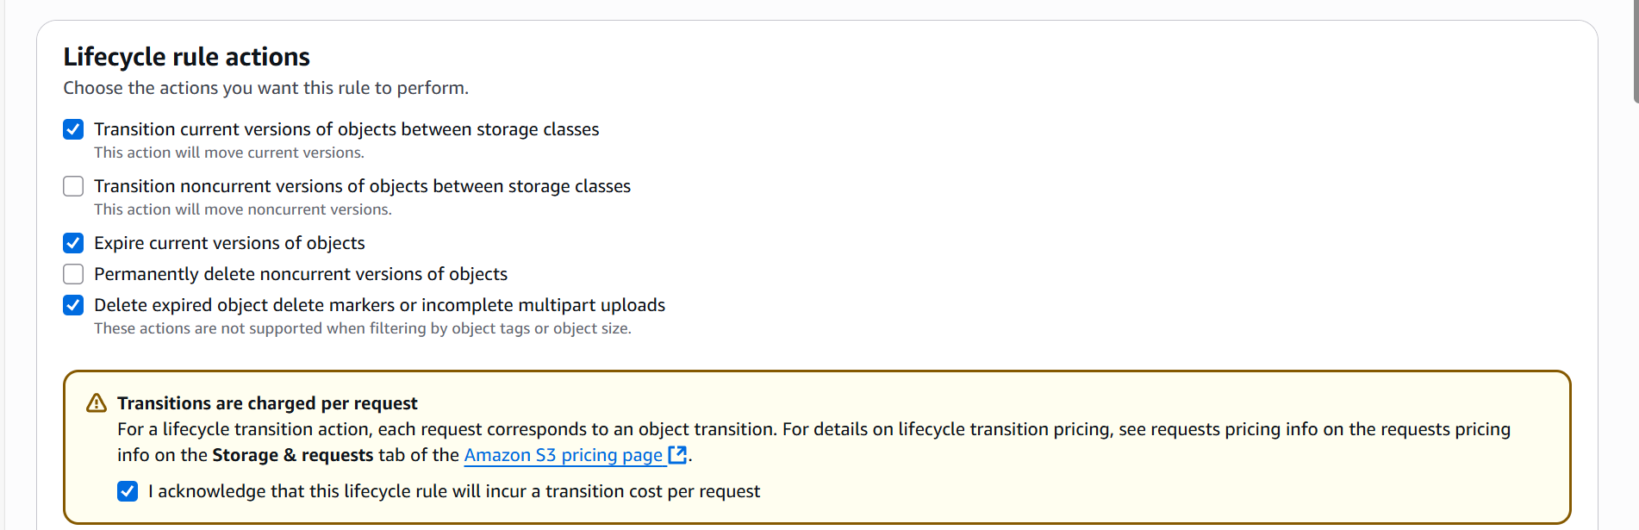

1. Under **Transition current versions of objects between** **storage classes:**

**Choose storage class transitions**: Select One zone- IA.

**Days after object creation**: Enter 30.

Click on Add transition button.

**Storage class transitions**: Select Glacier Flexible Retrieval (formerly Glacier).

**Days after object creation**: Enter 90.

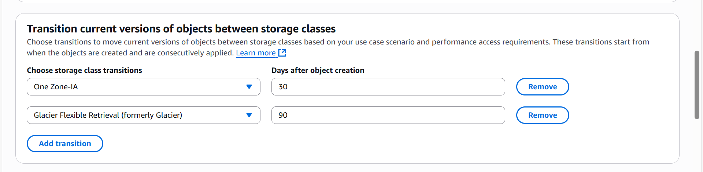

1. Under **Expire Under Current Object:**

**Days after object creation:** Enter 120.

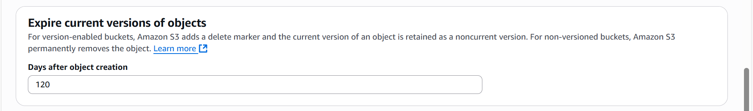

1. **Delete expired object delete markers or incomplete multipart uploads** :

**Incomplete multipart uploads**: Check the option of Delete incomplete multipart uploads.

**Number of days**: Enter 90.

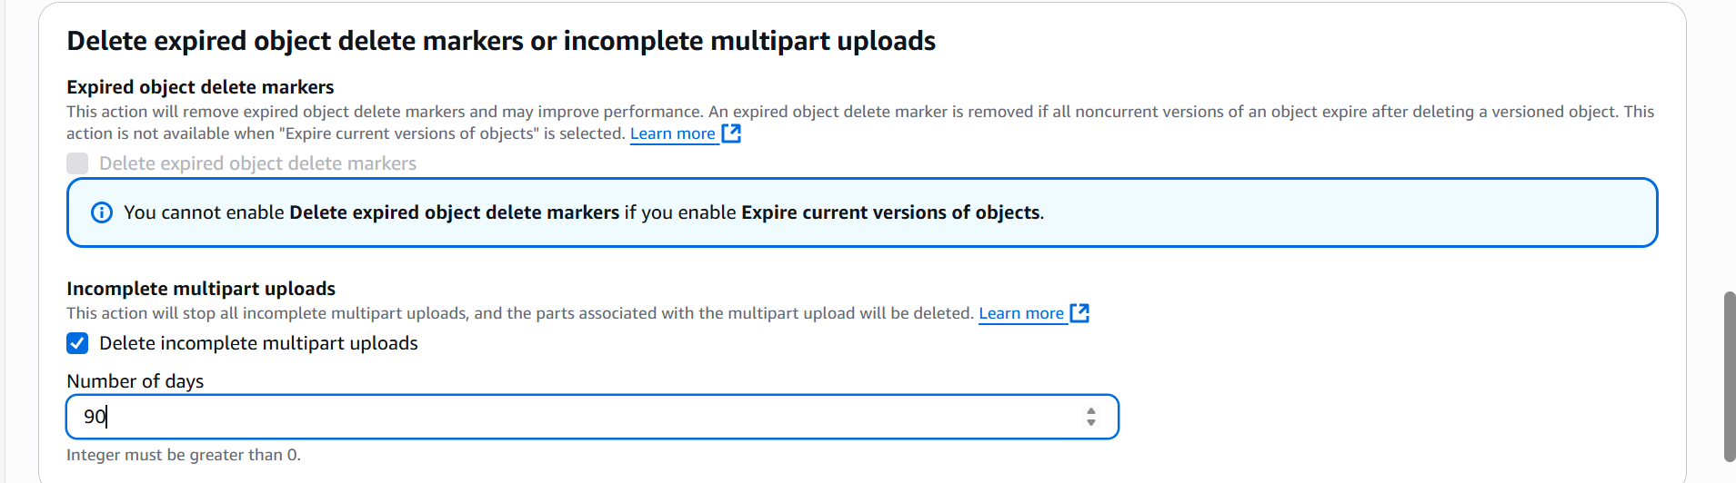

1. Now, **review** the transitions and click on **Create rule** present at the bottom right corner.

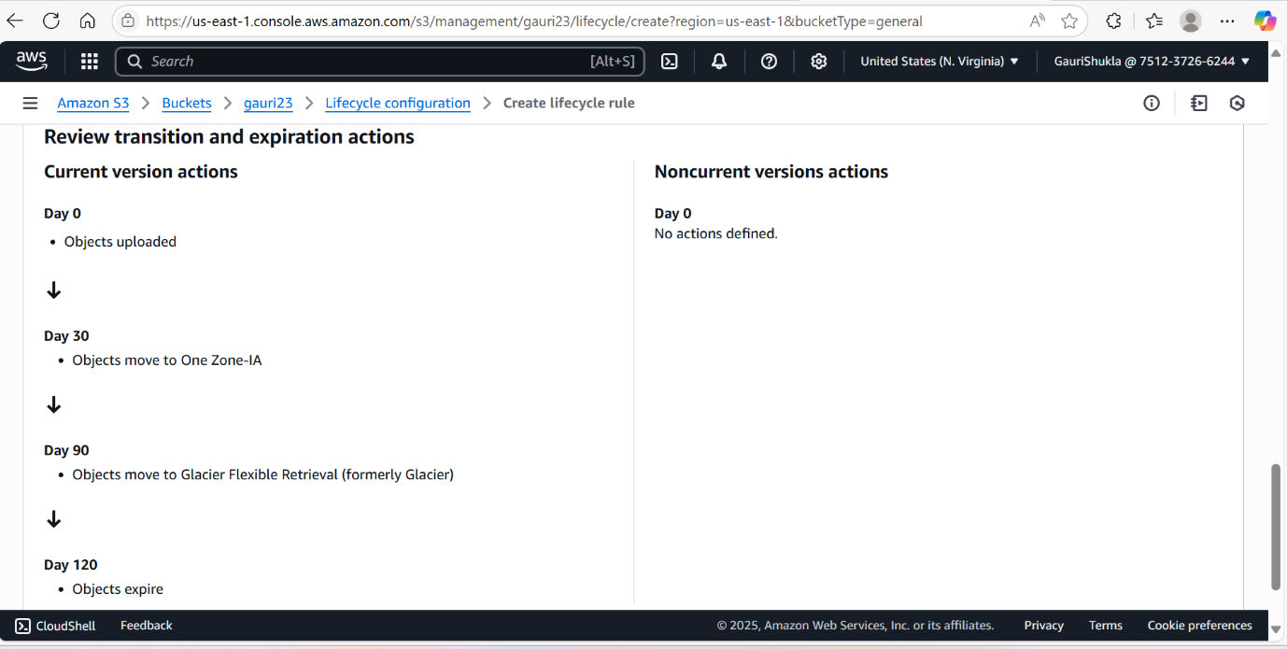

1. Now a lifecycle has been created.